
King Saud University
College of Computer and Information Science
Information Technology Department

SwE 482 Human-Computer Interaction
1ST Semester 2017/2018

Assignment 3

Group Number | 5
Section Number | 50136

Group Members
# | Name | ID
1 | Maram Dossari | 435201669
2 | Rawan Alajmi | 435201787
3 | Nour bamasoud | 435200338

Table of Contents
Home Screen 3
View Screen 4
Event Screen 5
Share an event 6
Copy link screen 7
Map option screen 8
Favourite events Screen 9
Book a ticket 10
Book a ticket screen 11
Book a ticket a screen 12
List view Screen 13
Map view Screen 14
Image option Screen 15
Search screen 16
Free ticket Screen 17
Taxi option Screen 18
Edit profile Screen 19
Image option Screen 20
prototype 21
Figure
Figure 1: home screen 3
Figure 2:view screen 4
Figure 3: event screen 5
Figure 4: share an event screen 6
Figure 5: copy link Screen 7
Figure 6: map option Screen 8
Figure 7: favourite events screen 9
Figure 8: book a ticket Screen 10
Figure 9: booked a ticket Screen 11
Figure 10: booked a ticket Screen 12
Figure 11: list view screen 13
Figure 12: map view Screen 14
Figure 13: image option Screen 15
Figure 14: search Screen 16
Figure 15: free ticket Screen 17
Figure 16: taxi option Screen 18
Figure 17: edit profile Screen 19
Figure 18: image option Screen 20
Figure 19: prototype 21

Home Screen
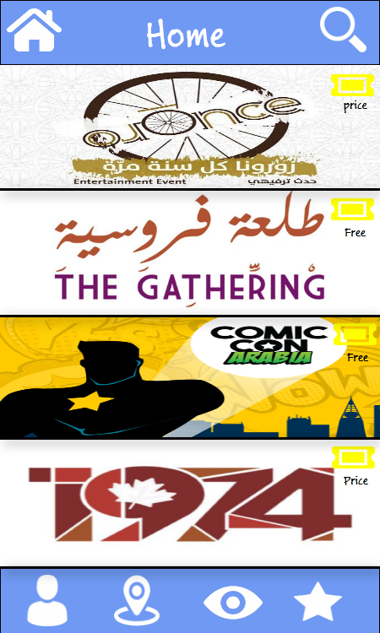
Figure 1: Home Screen

This the main page where the user can see every event and selects the desired event, furthermore in the bottom bar he/she can see her/his profile, view the events on the map, see the favourite events and change the view of the events (image, map, list).

View Screen
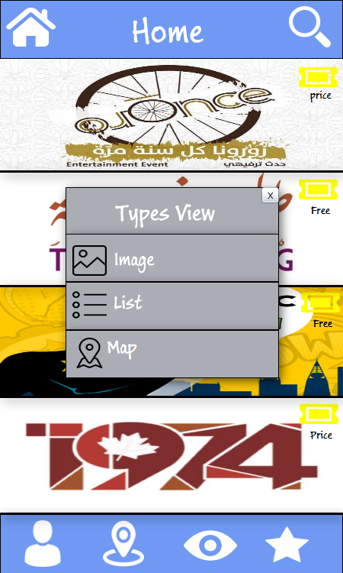
Figure 2: view screen
When the user select view option popup window will appear with the view options (image, map, list).

Event Screen
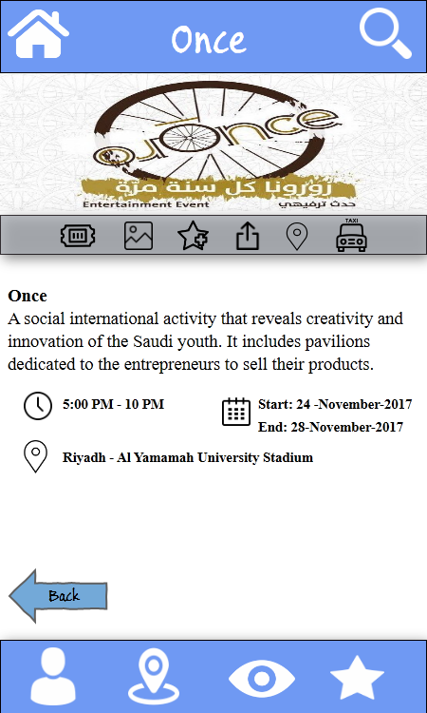
Figure 3: event screen

When the user selects an event he/she can see more details about that event with more options

Share an event
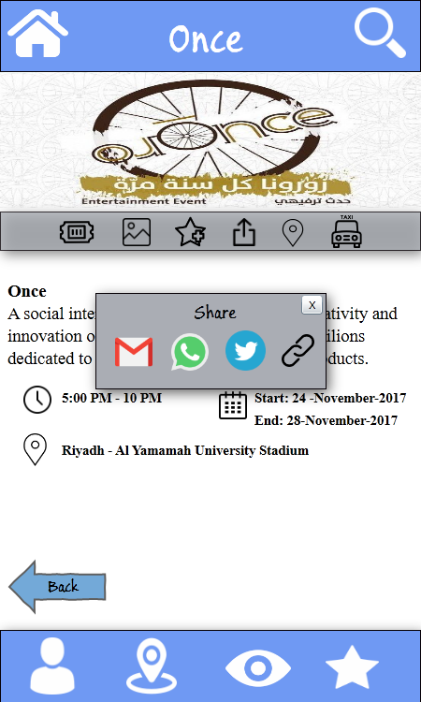
Figure 4: share an event screen
Every event page has many options one of them share option, the user be able to share favourite event by e-mail, whatsapp and twitter. Also he/she can copy the link to share it in other applications.

Copy link screen
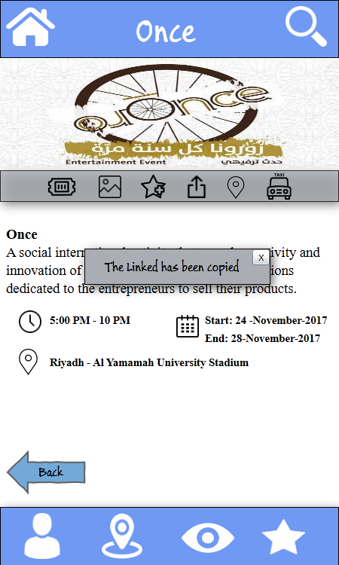
Figure 5: copy link Screen
When the user copies the links, he/she can see popup message which confirms that.

Map option screen
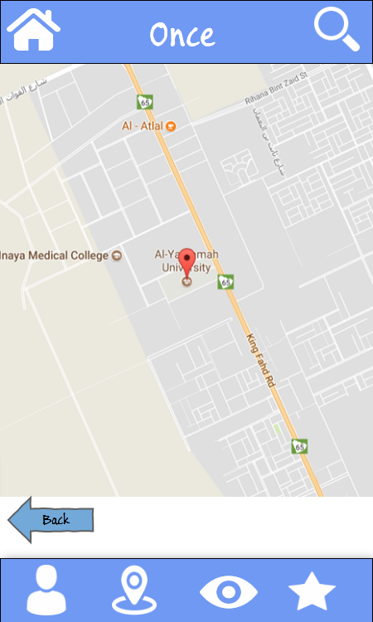
Figure6: map option Screen

When the user selects map option from event’s page, he/she can see the location of that event on the map

Favourite events Screen
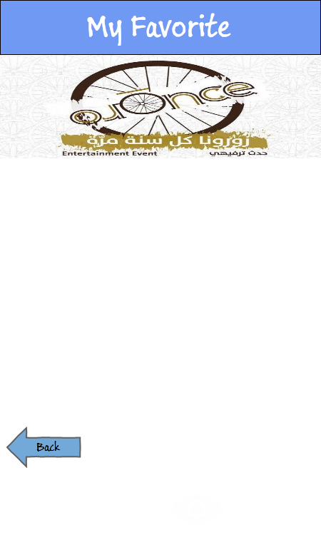
Figure 7: favourite events screen

When the user selects the favourite events option, he /she can see the favoured events.

Book a ticket Screen
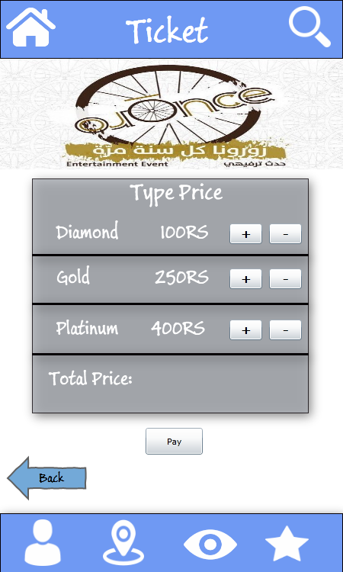
Figure8: book a ticket Screen
When the user selects ticket option from the event page. He/she can see the types of ticket with its price.

Book a ticket screen
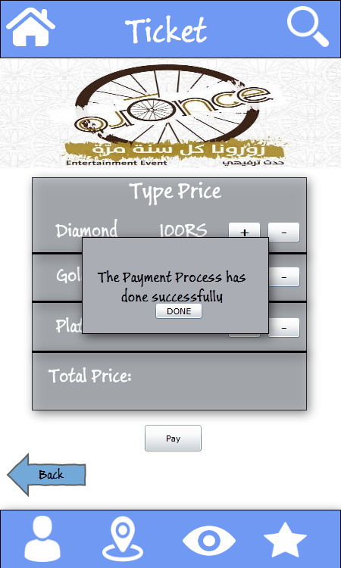
Figure 9: book a ticket Screen
When the user selects one of the tickets, and purchase that ticket he/she can see a message which confirms the payment.

Book a ticket a screen
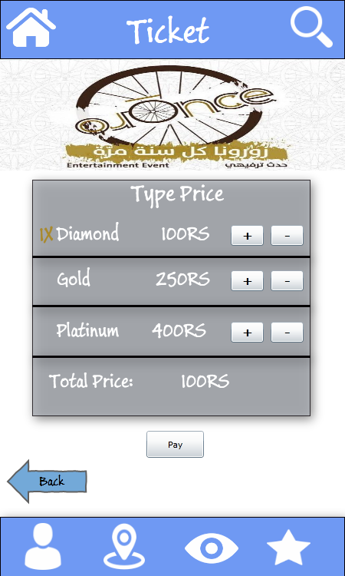
Figure 10: book a ticket Screen

In this page the user is able to select the quantity of tickets and see the total price.

List view Screen
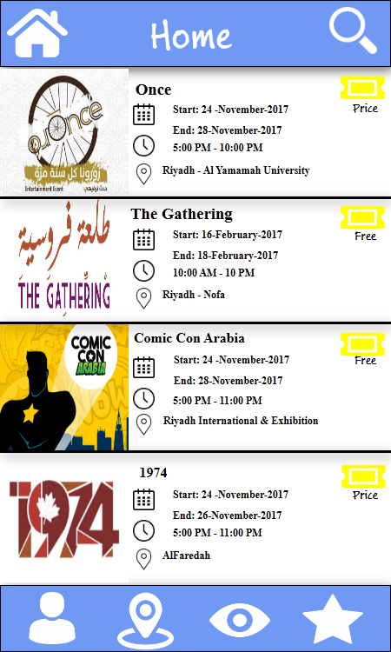
Figure 1: list view Screen
When the user selects the list view, he/she can see every event with its image and information.

Map view Screen
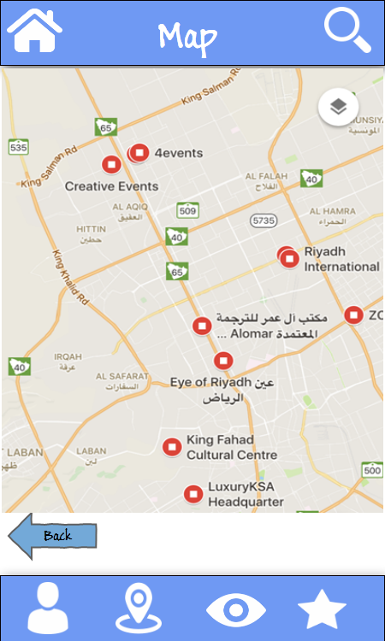
Figure 12: map view Screen
When the user selects the map view. He/she can see every event’s location on the map.

Image option Screen
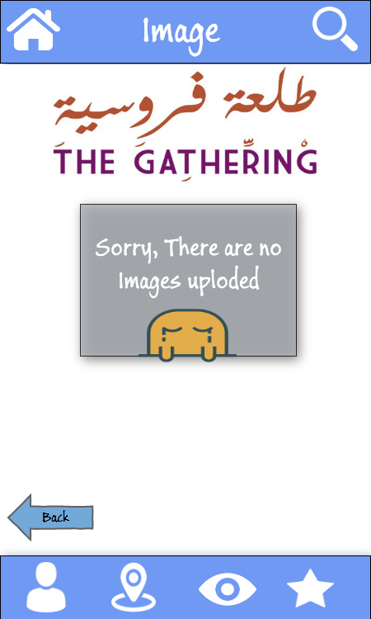
Figure 13: image option Screen

When the user selects image option from the event page. He/she can see the images uploaded related to that event. If there are no images he/she can see a popup message to indicate there are no images.

Search screen
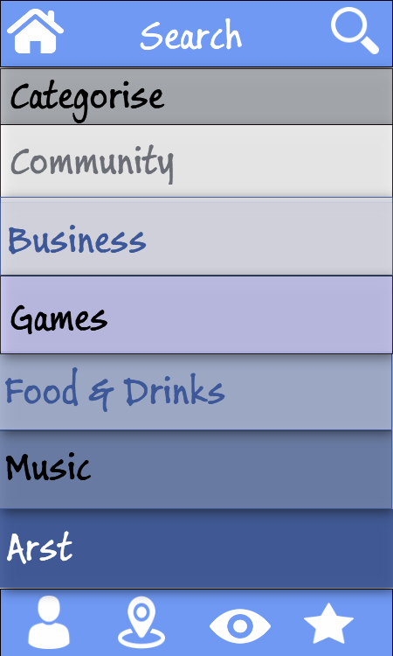
Figure 14: search Screen
In this page the user is able to search about an event and also provide the filters which make the search easier so when the user selects one of the filters he/she can see the related events to that category.

Free ticket Screen
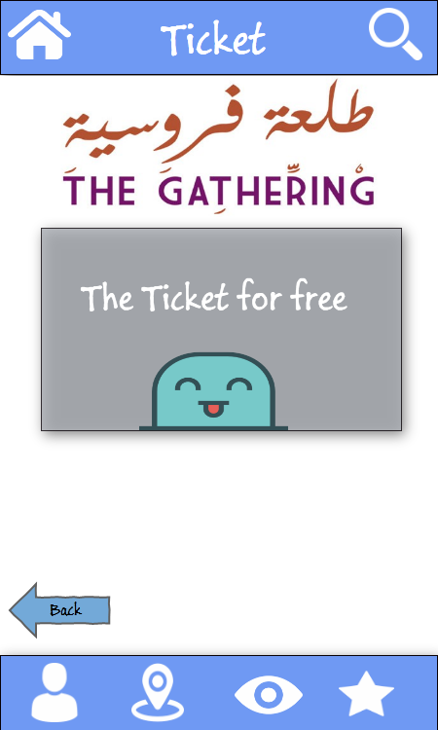
Figure 15: free ticket Screen
When the user selects ticket option from event page and the event is free. He/she can see popup message indicates that the event is free.

Taxi option Screen
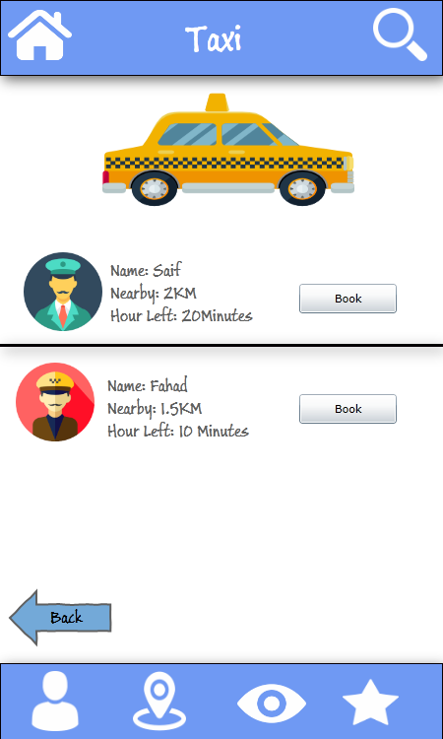
Figure 16: taxi option Screen
When the user selects the taxi option from event page. He/she can see the available taxi’s driver.

Edit profile Screen
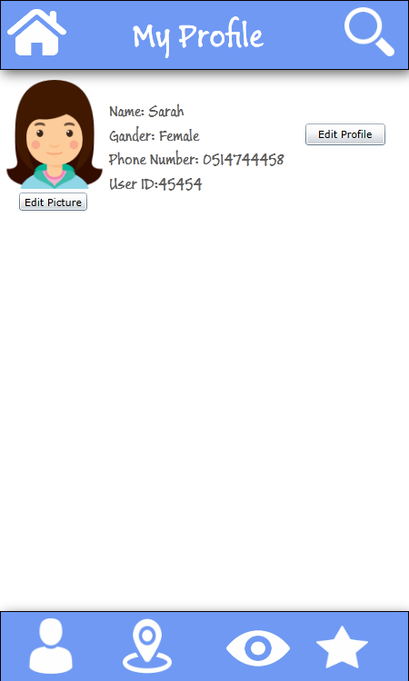
Figure 17: edit profile Screen

When the user selects the profile option from the bottom bar .he/she can see his/her information

Image option Screen
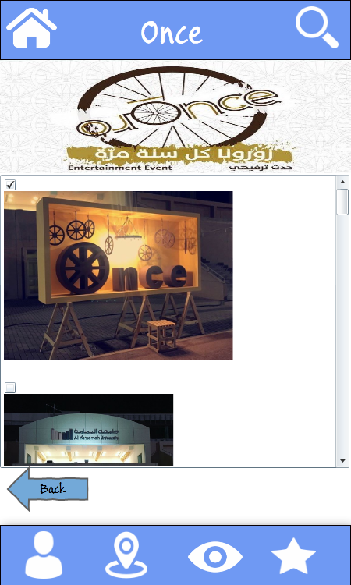
Figure 18: image option Screen

When the user selects image option from the event page. He/she can see the images uploaded related to that event

Prototype:
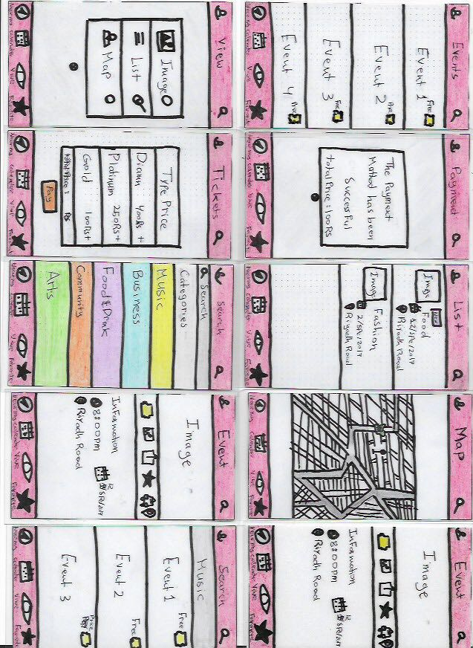
Figure 19: prototype

